## HISTORY OF NATIONAL AI DAY

### Ai Wei Wei is a Chinese activist and artist known in the East and West for his creative works. Because he is known for being politically outspoken and the divisive nature of his art, Wei Wei is persecuted by repressive government authorities. In 2005 he began using social media as a tool for social commentary. In 2009 his blog website was shut down. He moved to Twitter and continued online journaling from there, much to the dismay of the Chinese government. This led to Wei Wei’s house arrest in 2010 and subsequent arrest in 2011 at Beijing airport. He was then jailed for unspecified crimes but got released after serving three months in prison. Ai Wei Wei now lives in exile in Portugal and remains a critic of the Chinese Communist Party. . AI Attains Phenomenal Accuracy

AI achieves remarkable precision through deep neural networks, previously impossible. For instance, your interactions with Google Search and Alexa are all deep learning-based that keep getting more precise the more we use them. AI techniques are even used in the medical fields to discover cancer cells on MRIs with high precision as highly trained radiologists.

### 2. AI Is Reliable & Quick

AI performs frequent, voluminous, and computer-generated tasks reliably. However, for this, human skills are required to set up the system & ask proper questions.

### 3. AI Adds Intelligence To Products

AI won't be sold as an individual product. Instead, products that you use will be enhanced with AI integration, such as Apple products created a buzz with the Siri feature. Chatbots, automation, and smart devices together with massive data can improve several technologies at home and the workplace.

### 4. AI Evaluates Deeper Data

With [**big data**](https://www.hdatasystems.com/big-data) and computing power, it has been possible to develop a fraud detection system which was almost impossible a few years back. You require much data to train deep learning models as they learn straight from the data. The more the data, the more accurate they become.

### 5. AI Fully-utilized Data

You just need to implement AI in place to get the answers from the data. The role of data is more critical than ever before; it gives an edge over your competitors if you have the best data system in this competitive industry as the best data will win!

## Benefits Of Artificial Intelligence

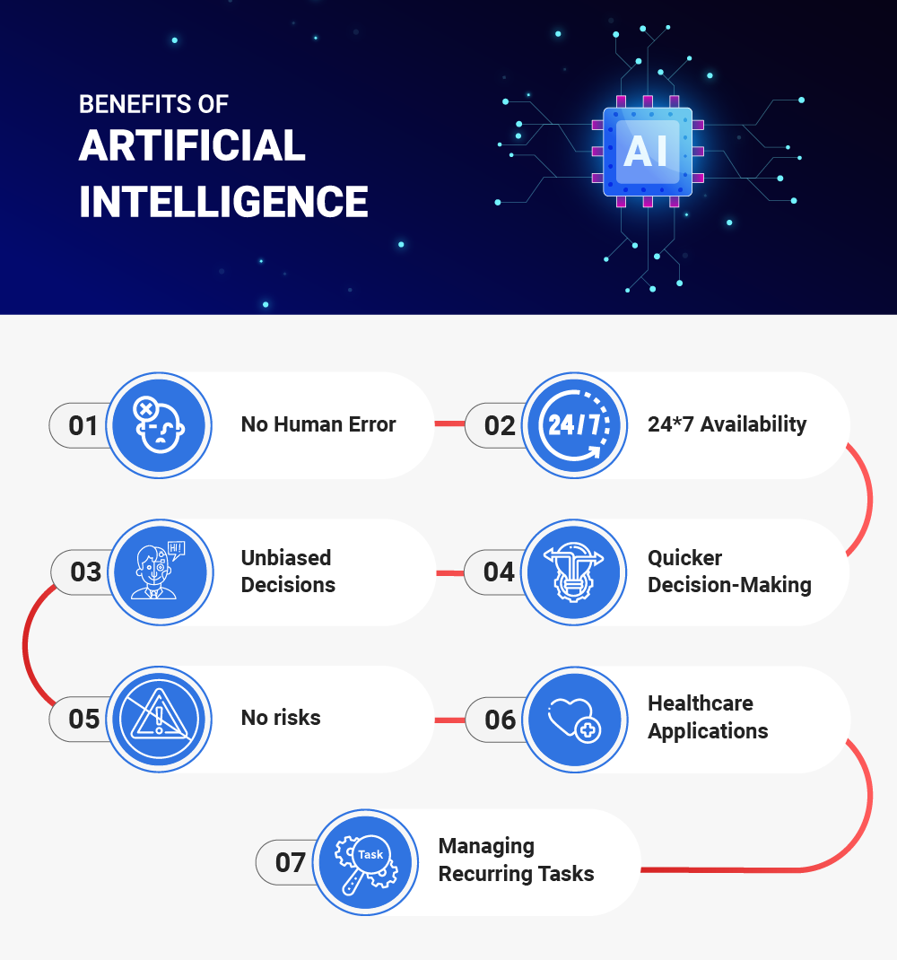

### 1. No Human Error

AI reduces errors, increasing the chances of accuracy and level of precision. Intelligent machines make precise decisions based on the past information they accumulate over time, implementing specific algorithms.

### 2. 24*7 Availability

Machines don't need lunch or coffee breaks, unlike human beings. They can work 24*7 without being bored or getting fatigued.

In November 2020, Google introduced Contact Center AI for companies to enhance customer experience. This is a great instance of an AI-based helpline system for companies to address customer queries and resolve issues continually.

### 3. Unbiased Decisions

Machines have no emotions, unlike emotionally driven humans. AI thinks more practically and has a rational approach. A big advantage of AI is that it does not have biased views, thus ensuring an accurate decision-making process.

### 4. Quicker Decision-Making

Intelligent machines can make decisions faster compared to humans. You might question the machine's decisions! But as discussed earlier, it makes decisions without any emotions and biased views. This ensures result-oriented decision-making.

For example, IBM's Deep Blue supercomputer makes decisions based on all the possibilities from the opponent's side. However, a human brain cannot fathom so many possibilities like a machine.

### 5. No Risks

Certain tasks can be hazardous for humans; however, machines can be a great alternative here. For example, allowing machines to handle a natural calamity can result in quicker recovery and lesser pressure on human teams.

This concept arises from Google & Harvard's initiative of building an AI system to forecast the aftershock locations of an earthquake. And after researching several earthquakes and their aftershocks, it displayed a higher degree of precision in pinpointing aftershock locations than conventional methods.

### 6. Healthcare Applications

AI techniques are highly utilized in the medical field. For instance, AI machines in healthcare devices have helped doctors evaluate the patient's health-related data and risk factors as well. It helps patients know the side effects of various medicines. Moreover, robotics is also used in treating mentally sick patients, such as depression.

At present, there is also software available to detect & monitor neurological disorders and stimulate the human brain's functionality.

### 7. Managing Recurring Tasks

Repetitive tasks are monotonous in nature. And such tasks can be easily managed with AI's help. Intelligent machines process much faster and can perform several tasks at once to generate the best outcomes. These intelligence machines save a lot of humans, and they can focus on more complex tasks.

**Explore More:**[**Transformation Drives AI & Vice Versa - Video Analytics**](https://www.hdatasystems.com/blog/transformation-drives-ai-vice-versa-video-analytics)

## Four Types of Artificial Intelligence

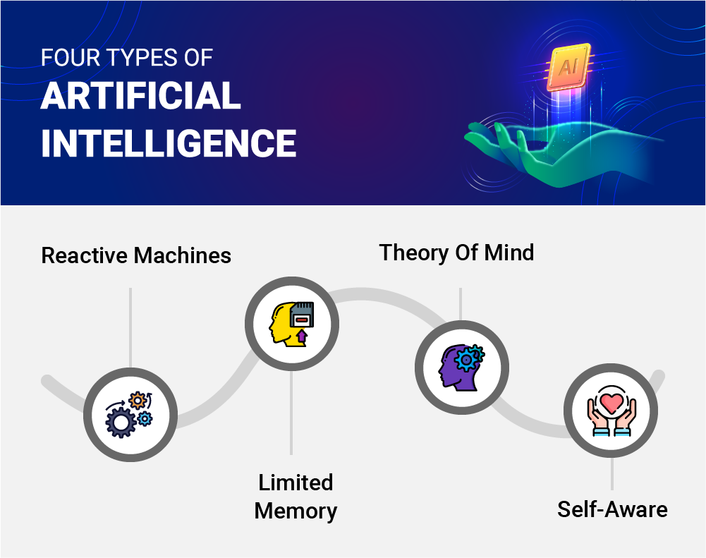

## ****Applications Of Artificial Intelligence****

